**A** **PRELIMINARY** **REPORT** **ON**

**COMPLAINT BOX FOR SOCIAL WELFARE**

SUBMITTED TO THE SAVITRIBAIPHULE PUNE UNIVERSITY,PUNE

IN THE PARTIAL FULFILLMENT OF THE REQUIREMENTS

FOR THE AWARD OF THE DEGREE

**BACHELOR** **OF** **ENGINEERING**

**(COMPUTER** **ENGINEERING)**

**SUBMITTED** **BY PRN NO.**

**Sanket Sabale 72174750H**

**Vaibhav balghare 72174731M**

****

**DEPARTMENT** **OF** **COMPUTER** **ENGINEERING**

**SRTCT’S**

**SUMAN** **RAMESH** **TULSIANI** **TECHNICAL** **CAMPUS,** **FACULTY** **OF** **ENGINEERING,**

**PUNE** **410405**

**SAVITRIBAI** **PHULE** **PUNE** **UNIVERSITY** **2022-23**

****

**CERTIFICATE**

This is to certifythat the project report entitles

**“COMPLAINT BOX FOR SOCIAL WELFARE”**

**SUBMITTED** **BY PRN NO.**

**Sanket Sabale 72174750H**

**Vaibhav balghare 72174731M**

is a bonafide student of this institute and the work has been carried out under the supervision of **Prof.** **Anjali M.** **Dalvi** and is approved for the partial fulfillment of the requirement of Savitribai Phule Pune University, for the award of the degree of **Bachelor** **of** **Engineering** (Computer Engineering).

**Prof.** **Anjali** **M.** **Dalvi Prof.** **Suresh** **V.** **Reddy**

Guide Project Coordinator

Department of Computer Engineering Department of Computer Engineering

**Prof.** **Anjali** **M** **Dalvi** **Prof.** **(Dr.)** **J.** **B.** **Sankpal**

Head of Department Principal

Department of Computer Engineering SRTTC-FoE, Kamshet

Place: Khamshet,Pune.

Date:

**ACKNOWLEDGEMENT**

It gives us great pleasure in presenting the preliminary project report on **“COMPLAINT BOX FOR SOCIAL WELFARE”.**

Wewould liketo takethis opportunityto thankour internal guide **Prof.** **Anjali** **M.Dalvi** for giving us all the help and guidance we needed. We are grateful to them for their kind support and motivation throughout. Their valuable suggestions were very helpful.

We are also grateful to **Prof.** **Anjali** **M.** **Dalvi,** Head of the Computer Engineering, Suman Ramesh Tulsiani Technical Campus: Faculty of Engineering, Kamshet, Pune for her indispensable support and suggestions.

We are also grateful to **Prof.** **Dr.** **J.** **B.** **Sankpal,** Principal**,** Suman Ramesh Tulsiani Technical Campus: Faculty of Engineering, Kamshet, Pune for his indispensable support and suggestions.

**SUBMITTED** **BY PRN NO.**

**Sanket Sabale 72174750H**

**Vaibhav balghare 72174731M**

**ABSTRACT**

These is a sponsor project by sameer jawalkar he is the vice president of pimpri-chinwad city and he wants to create an app that can understand the voters problem in there society without contacting any third-party member they can directly contact to him so these is the main objective behind these project. these is an android app but by using the cross platform technology we can create it for ios as well with single code base with many functionalities these app is required some basic authentication and get access of many things like chacking that you are under sameer jawalkar ward or you can see your details you can fill a form for complaint as we with minimum information like name,mobile,location (auto picked ) and complaint thats it if some user is don’t want to fill the form and its urgent then you will get a button for directly contact via whatsapp just one click away from it so the complaint box functionality is become easy but the main thing is form admin side.

Yes we are Developing one more app for admin for accessing and getting all complaint after resolving the issue the voter/user will get a notification for that so not only that but admin app can handle almost all thing in app like sending any post or modify any data like that these app is specifically made for sameer jawalkar so it not going to be public and its has more secure authenticatio as well so admin app and user app both are necessary to create for better outcome.

Android and IOS App development become more complex if we try to create it from different codebase also its to much for time consumption so we are going to use react native for cross platform development. with single codebase we can generate an app for both platform and to publish these apps we are using app store for ios and play store for android app so that anyone can download from anywhere by just searching the name of app.

**TABLE** **OF** **CONTENTS**

**I** **INTRODUCTION** **1**

1.1 Overview...………………………… 2

1.1.1 Motivation………………………………….. 3

1.1.2 Objectives ………………………………….. 3

**II** **LITERATURE** **SURVEY** **4**

2.1 Studyof Research Papers……………………………. 5

**III** **POJECT** **REQUIREMENT** **8**

3.1 External interface requirement……………………… 9

3.1.1 User Interface ……………………………… 9

3.1.2 Hardware Interfaces………………………... 9

3.1.3 Software Interfaces………………………… 9

3.2 Non-functional requirement…………………………. 10

3.2.1 Performance Requirements………………... 10

3.2.2 Safety Requirement ………………. 10

3.1.4 Software Quality Attributes ………………. 10

**IV** **SYSTEM** **ANALYSIS** **12**

4.1 System Architecture………………………………….. 12

4.1.1 Data Flow Diagram………………. 13

4.1.2 EntityRelationship Diagram………………. 14

4.2 UML Diagrams ……………………………………… 16

**V** **PROJECT PLAN** **21**

5.1 Overview of Project Implementation………………… 21

5.2 Tools and Technology……………………………….. 21

5.3 Software Information ………………………………... 22

**VI METHODOLOGY** **24**

6.1 Algorithm Details ………………………………….. 24

**VII CONCLUSION** **27**

**VIII REFERENCES** **29**

**LIST** **OF** **FIGURES**

Figure 4.1 System Architecture ...................................... 14

Figure 4.2 Data Flow diagram-0..................................... 15

Figure 4.3 Data Flow diagram-1..................................... 15

Figure 4.4 Data Flow diagram-2..................................... 16

Figure 4.5 ER diagram..................................... 17

Figure 4.6 Use Case diagram..................................... 18

Figure 4.7 Activity diagram..................................... 19

Figure 4.8 Sequence diagram..................................... 20

Figure 4.9 Class diagram..................................... 21

Figure 7.1 Working of CF Algorithm ................................ 28

**LIST** **OF** **TABLES**

Table 2.1.1 Summary of Research Papers

**CHAPTER**

**I**

**INTRODUCTION**

**1.1 OVERVIEW**

We picked react native for cross platform development just because its easy for understand and many different libraries and more databases have supported well that make app less complicated to create. also react native is a great platform for a developer who comes from react world its become easy if you basic of react but some measure concepts about html and css for design stuff and we have those knowledge so these may a reason to pick up these tech stack. react native comes with so many thinks like a cli but we are not using the cli because its more complex to handle so we are using expo for some better experience we are generated our basic information that we need to generate and we fill like the expo and its internal libraries are more than enough for us to fullfill our requirements so react native with expo is make our code better and performace will high.

React Native is an Open Source Framwork created by facebook ( meta ) it is used to develop application for android and ios. The working principles of React Native are virtually identical to [React](https://en.wikipedia.org/wiki/React_(JavaScript_library)" \o "React (JavaScript library)) except that React Native does not manipulate the [DOM](https://en.wikipedia.org/wiki/Document_Object_Model" \o "Document Object Model) via the [Virtual DOM](https://en.wikipedia.org/wiki/React_(JavaScript_library)" \l "Virtual_DOM" \o "React (JavaScript library)). It runs in a [background process](https://en.wikipedia.org/wiki/Background_process" \o "Background process) (which interprets the [JavaScript](https://en.wikipedia.org/wiki/JavaScript" \o "JavaScript) written by the developers) directly on the end-device and communicates with the native platform via [serialized data](https://en.wikipedia.org/wiki/Serialization" \o "Serialization) over an [asynchronous](https://en.wikipedia.org/wiki/Asynchrony_(computer_programming)" \o "Asynchrony (computer programming)) and [batched](https://en.wikipedia.org/wiki/Batch_processing" \o "Batch processing) bridge. React components wrap existing native code and interact with native APIs via React's [declarative UI paradigm](https://en.wikipedia.org/wiki/Declarative_programming" \o "Declarative programming) and [JavaScript](https://en.wikipedia.org/wiki/JavaScript" \o "JavaScript). While React Native styling has a similar syntax to CSS, it does not use [HTML](https://en.wikipedia.org/wiki/HTML" \o "HTML) or [CSS](https://en.wikipedia.org/wiki/CSS" \o "CSS). Instead, messages from the JavaScript thread are used to manipulate native views. Without React Native, developers have to write native code in the languages of the aimed platform such as [Java](https://en.wikipedia.org/wiki/Java_(programming_language)" \o "Java (programming language)) or [Kotlin](https://en.wikipedia.org/wiki/Kotlin_(programming_language)" \o "Kotlin (programming language)) for [Android](https://en.wikipedia.org/wiki/Android_(operating_system)" \o "Android (operating system)), [Objective-C](https://en.wikipedia.org/wiki/Objective-C" \o "Objective-C) or [Swift](https://en.wikipedia.org/wiki/Swift_(programming_language)" \o "Swift (programming language)) for [iOS](https://en.wikipedia.org/wiki/IOS" \o "IOS), and [C++/WinRT](https://en.wikipedia.org/wiki/C++/WinRT" \o "C++/WinRT) or [C#](https://en.wikipedia.org/wiki/C_Sharp_(programming_language)" \o "C Sharp (programming language)) for [Windows 10](https://en.wikipedia.org/wiki/Windows_10" \o "Windows 10).

React native can save out time because 95% or more of the code is cross-platform, meaning it is compatible with both Android and iOS, developers only need to build one app, and in the end two apps are created. This saves time in development of the app, which saves a lot of money that would have been put into building separate apps. With React Native businesses can have both apps at once for little more than half the cost of building one version. Companies no longer have to choose which version to build and launch first due to the cost of building two separate apps. In addition maintenance and updates are done on both apps at the same time which saves on future costs once the apps are built and launched. also React Native apps perform almost exactly like a native app that was built on the specific iOS or Android platform. They are also fast because the programming language is optimized for mobile devices. Instead of mainly using the central processing unit (CPU), React Native apps take advantage of the graphics processing unit (GPU). This makes them much faster than cross-platform hybrid technologies. The type of interface used in React Native makes it easy for different developers on a team to jump in where someone else left off and continue building. This increases team flexibility, and makes it easier to update and upgrade the mobile app. It also creates flexibility for testers who are able to create testing scenarios much easier. These advantages also contribute toward saving time and money. Publishing updates for your app used to take a lot longer, requiring developers to go through a build process again with each app separately. With React Native that process has been streamlined. Not only can both apps be updated at the same time, but the whole process is much simpler and can be done much faster. As you create improvements and updates for your users, developers implement them through over the air (OTA) updates, which are implemented even as users are using the app. Then, the next time the app is opened, the update is ready for the user. There is no longer a need to update the app through the app stores manually and have them approved by Apple or Android, which saves time and makes the process much more streamlined.

* + 1. **MOTIVATION**

These app can be solve so many problems like if someone want to complaint about power issue in there society and nobody responding on it then these is complaint box application can take the compaint and directly send to the admin app so that no third party is involved in these case and there are high chances that the problem will solve in few days and admin is able to reply that person as well in some situation if user want to see that he is in the ward or not? then in these app we have special access of voter id where you can search your name in any format like first,last name so there is no issue with that you will get the better result and for admin they can post more blogs and images so that he can connect with people all the time and every user can share with you his feedback as well so it solve more problem in users daily life.

* + 1. **OBJECTIVES**

Complaint Box app Contains so many section in one of them is Fill Your Complaint or Complaint support not only that but also about me section for understanding sameer jawalkar info, voter id for finding user name is consider in ward or not, blog where user can see the post that admin send to app for user, for joining his team user can send an application (form ) with these section also feedback for app if user think something can be improved then he contact to admin directly but all these feature can be access to user if he logged in or register with valid mobile authentication. admin also have app that can manage the whole things in users app accessing all appointments / request or complaints also sending post editing it sending photos and chainging social media links and almost all things which user app is required to have these is some basic features of admin and user app. process to users app is first is user is new then user need to give his own details and then a small mobile number verification and user can able to access the app feature also the one time login feature is implemented here so user don’t need to login again and again all the login credentials are stored in local storage so user can easily open application with fast scalability.

**CHAPTER**

**II**

**LITERATURE** **REVIEW**

**2.1** **STUDY** **OFRESEARCH** **PAPERS**

|  |  |  |  |
| --- | --- | --- | --- |
| **Sr.No** | **Title of Paper and year** | **Methodology** | **Findings** |
| 1 | Authentication Model using the Bundled  CAPTCHA OTP Instead of Traditional Password | Secure moblile authentications | getting ready for captcha in valid mobile authentication system in application for validation of human. |
| 2 | A Customer Complaint Analysis Tool for Mobile  Network Operators | Understanding complaints from users | understading how we can able to handle same sort of complaints more many users. |
| 3 | Analysis of Cross-Platform Mobile App Development Tools | Cross app development | Developing app on both android and ios with single codebase |

1. **Paper** **Name:** **Library** **Intelligent** **Book** **Recommendation** **System** **Using** **Facial** **Expression** **Recognition**

**Author :** Thivanon Kansuwan, Thawatchai Chomsiri \_x0005\_

**Abstract :** In this research, we present identity verification using the "Bundled CAPTCHA OTP" instead of using the traditional password. This includes a combination of CAPTCHA and One Time Password (OTP) to reduce processing steps. Moreover, a user does not have to remember any password. The Bundled CAPTCHA OTP which is the unique random parameter for any login will be used instead of a traditional password. We use an e-mail as the way to receive client-side the Bundled CAPTCHA OTP because it is easier to apply without any problems compare to using mobile phones. Since mobile phones may be crashing, lost, change frequently, and easier violent access than e-mail. In this paper, we present a processing model of the proposed system and discuss advantages and disadvantages of the model.

1. **Paper** **Name:** A Customer Complaint Analysis Tool for Mobile Network Operators.

**Author :** Feyzullah Kalyoncu, Engin Zeydan, Ibrahim Onuralp Yigit, Ahmet Yildirim.

**Abstract :** Mobile Network Operators (MNOS) are eager to learn more about complaint behaviour of their subscribers. In this demo, we study topic modeling approach for extract- ing relevant problems experienced by subscribers of MNOS in Turkey and visualize the topic distributions using LDAvis data analytics tool. For building topic models using Latent Dirchlet Allocation (LDA), we have built customer complaint text dataset of subscriber complaints for each MNOS from Turkey's largest customer complaint website. The proposed analysis tool can be used as customer complaint analysis service by MNOS in Turkey to gain more insight. We have also validated our generated topic model using another dataset obtained from Turkey's largest online community website. Our results indicate similar and dissimilar topics of complaints as well as some of the distinctive problems of MNOS in Turkey based on their subscriber's experiences and feedback.

1. **Paper Name :** Analysis of Cross-Platform Mobile App Development Tools

**Author :** kewal shah,Harsh sinha.

**Abstract :** With the emergence of different cross-platform alternatives, there is a need to explore the various approaches the developer must take. We perform this study in the hopes of shedding more light on their differences and highlighting the critical aspects which make them unique. The examination of these WORA (Write Once, Run Anywhere) mobile App tools is done on the basis of different approaches, i.e., Native apps, Web apps, Hybrid apps, Interpreted apps and Widget-based apps. The study performed shall enable us to illustrate the results on the basis of these categories.

**CHAPTER**

**III**

**PROJECT REQUIREMENT**

* 1. **EXTERNAL** **INTERFACE** **REQUIREMENT**

**3.3.1** **USER** **INTERFACES**

Android and IOS application for Interacting with complaint box with more functionality.

**3.3.2** **HARDWARE** **INTERFACES**

* Hardware :Intel i5 and M1
* Speed : 3 GHz
* Ram : 16 GB
* HardDisk : 512 SSD
* KeyBoard : Standard Windows Keyboard

**3.3.3** **SOFTWARE** **INTERFACES**

* Operating System : Windows and Mac
* Software IDE : Visual Studio code
* Emulator : android Emulator and Ios Simulator
* Database : Firebase

**3.2** **NON-FUNCTIONAL** **REQUIREMENTS**

**3.4.1** **PERFORMANCE** **REQUIREMENT**

The performance of the functions and every module must be well. The overall performance of the software will enable the users to work efficiently. Performance of encryption of data should be fast. Performance of the providing virtual environment should be fast Safety Requirement. The application is designed in modules where errors can be detected and exceed easily. This makes it easier to install and update new functionalityif required.

**3.4.2** **SAFETY** **REQUIREMENT**

The application is designed in modules where errors can be detected and fixed easily. This makes it easier to install and update new functionalityif required.

**3.4.3** **SOFTWARE** **QUALITY** **ATTRIBUTES**

Our software has manyqualityattributes that are given below: -

Adaptability: This software is adaptable to all users.

Availability: This software is freely available to all users. The availability of the software is easy for everyone.

Maintainability: After the deployment of the project if any error occurs then it can be easilymaintained bythe software developer.

Reliability: The performance of the software is better which will increase the reliabilityof the Software.

User Friendliness: Since the software is a GUI application; the output generated is much user friendlyin its behavior.

Integrity: Integrity refers to the extent to which access to software or data by unauthorized persons can be controlled.

Security: Users are authenticated using many security phases so reliable security is provided.

Testability: The software will be tested considering all the aspects.

**CHAPTER**

**IV**

**SYSTEM** **ANALYSIS**

**4.1** **SYSTEM** **ARCHITECTURE**

**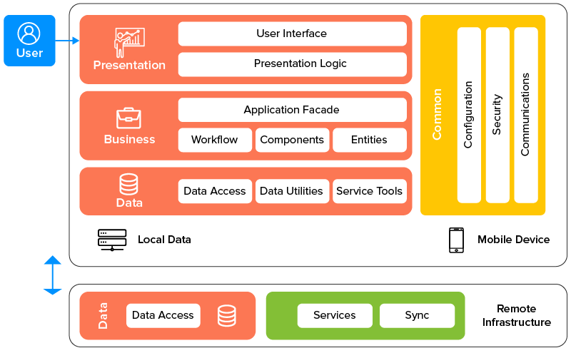**

Figure 4.1.1 Proposed System Architecture

The above figure 4.1.1 defines the workflow of the project in a very simple way.

From figure 4.1.1 Proposed System Architecture, user need to register first with its valid details and then user can access all the fields also these app consist local database for storing login details also it store 34k+ voter data so in offline mode as well user can be able access thing in these app so all the online database from online mode is firebase for accesssing all the details firebase comes with nosql database so we getting is in json file and thoughout these app we are going to represent it in app for accessing blog that admin send us in single page we are getting all the data once and can see one by one each in detail in different pages data accessing or getting from data may be solve so sycronization also takes care in these approach. so there are so many things are actually present in app like profile modification per user it at the time of login user are giving us small amount of info but profile page can be able to add more details and change it as well so the architechture is with fields like local data used for storing some limited data set in offline maner, mobile device for accessing those local data but its totally depend on configuration and performance of device security also take a place here and Database access there are quiet a bit of thing are accessing from online but we have thing to get it in point like latest detail will be posted up earlier.

**4.1.1 DATA** **FLOW** **DIAGRAMS**

In data flow diagram we are expecting of authentication with mobile number thats why these diagram show the flow of authentication where first user are going to register with its valid details and then the data goes to the database after that firebase furform some operation that is about authenticate give number and after that user can see the homepage.

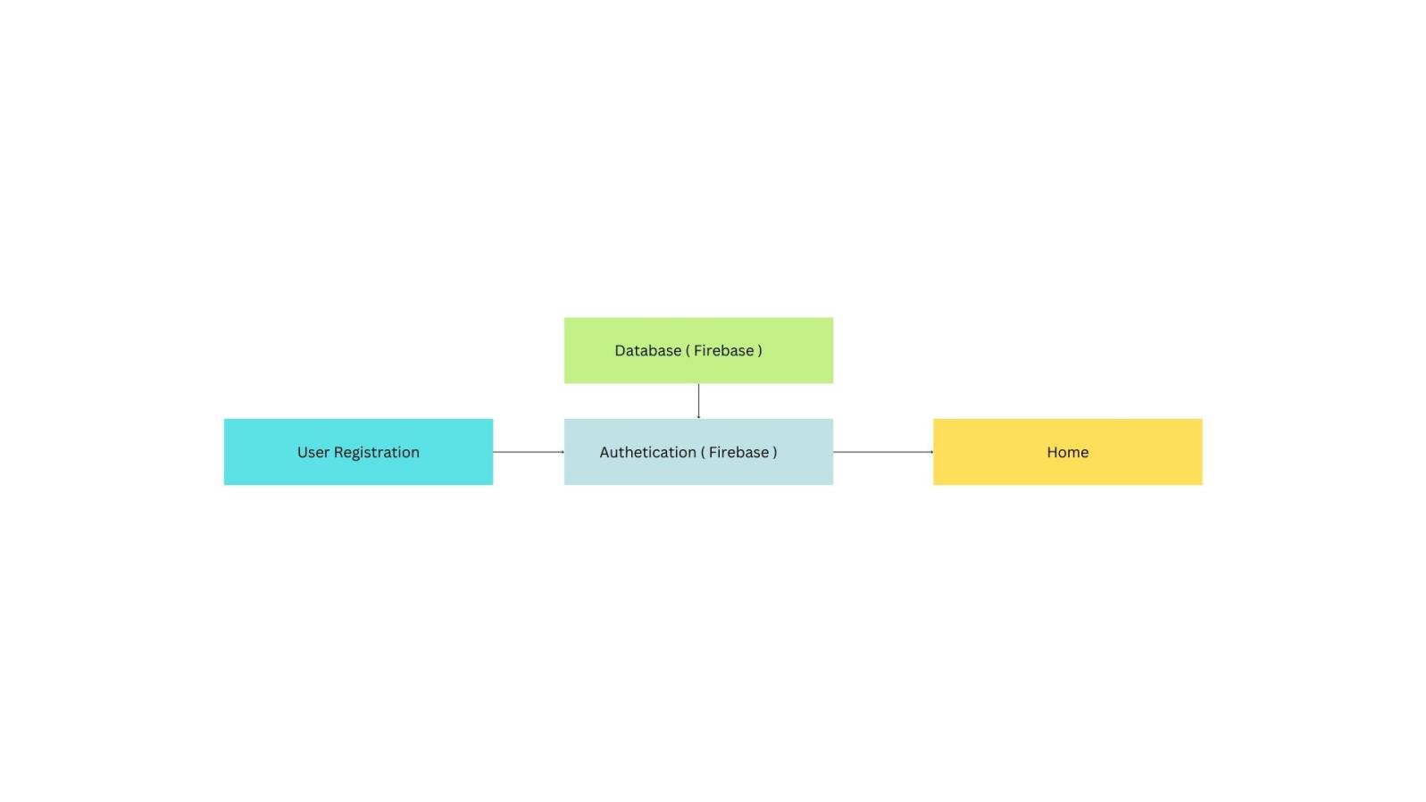

Figure 4.2.2: Data Flow Diagram-0

The above figure 4.2.2 DFD Level-0 (Context Diagram) gives the basic overview of the whole system or process being analyzed or modeled.

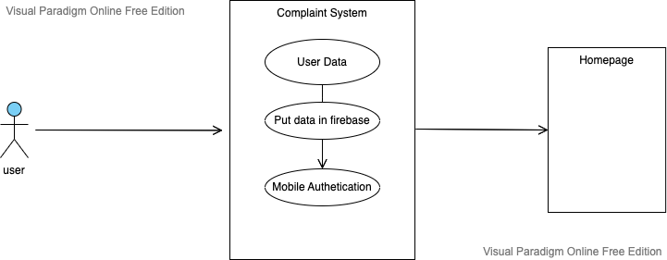

Figure 4.2.3 Data Flow Diagram-1

The above figure 4.2.3 DFD Level-1, highlights the main functions of the system and breakdown the high-level process of the DFD-0 level

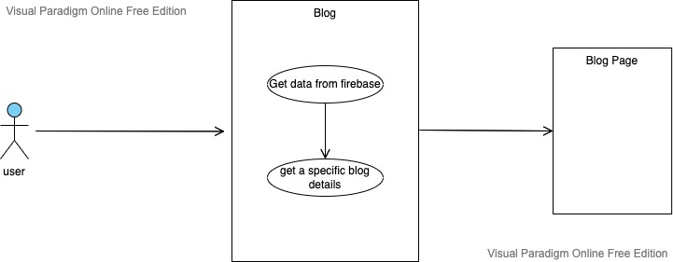

Figure 4.2.4 Data Flow Diagram-2

The above figure 4.2.4 DFD Level-2, goes one step deeper into parts of 1-level DFD as it specifies the necessary detail about the system’s functionality.

**4.1.2** **ENTITY-RELATIONSHIP** **DIAGRAM**

ER Diagram stands for Entity Relationship Diagram, also known as ERD is a diagram that displays the relationship of entity sets stored in a database. In other words, ER diagrams help to explain the logical structure of databases. ER diagrams are created based on three basic concepts: entities, attributes, and relationships. ER Diagrams contain different symbols that use rectangles to represent entities, ovals to define attributes, and diamond shapes to represent relationships. The purpose of ER Diagram is to represent the entityframework infrastructure.

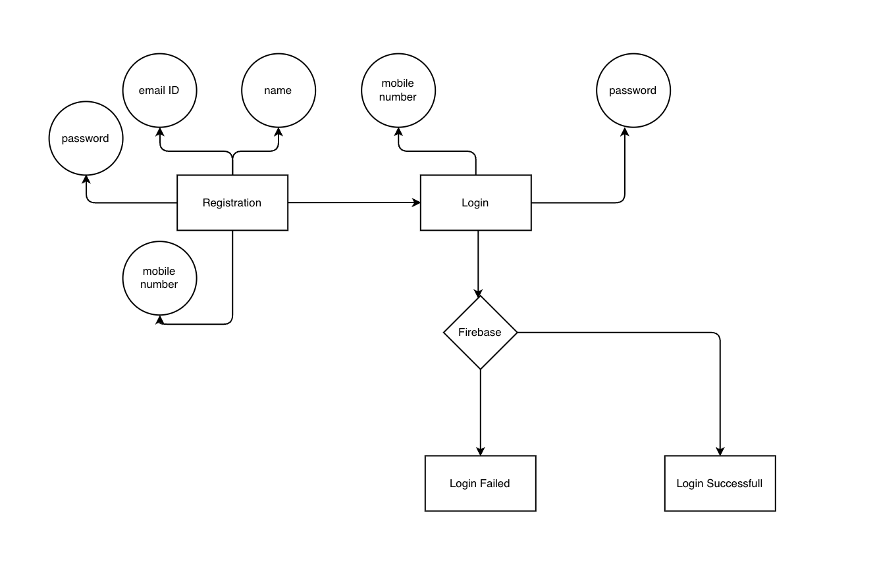

Figure 4.3.6 ER Diagram

The ER diagram is necessary at the planning stage of software development. The above figure 4.3.6 ER diagram, illustrates how different entities of the system are co-related with each other.

**4.2** **UML** **DIAGRAMS**

Unified Modeling Language is a standard language for writing software blueprints. The UML may be used to visualize, specify, construct and document the artifacts of a software-intensive system. UMLis process independent, although optimallyit should be used in the process that is use case driven, architecture-centric, iterative, and incremental. The Number of UML Diagram is available such as:

* Use case Diagram.
* ActivityDiagram.
* Sequence Diagram.
* Class Diagram

1. **USE** **CASE** **DIAGRAM**

A use case diagram is a graphical depiction of a user's possible interactions with a system. A use case diagram shows various use cases and different types of users the system has and will often be accompanied by other types of diagrams as well.

**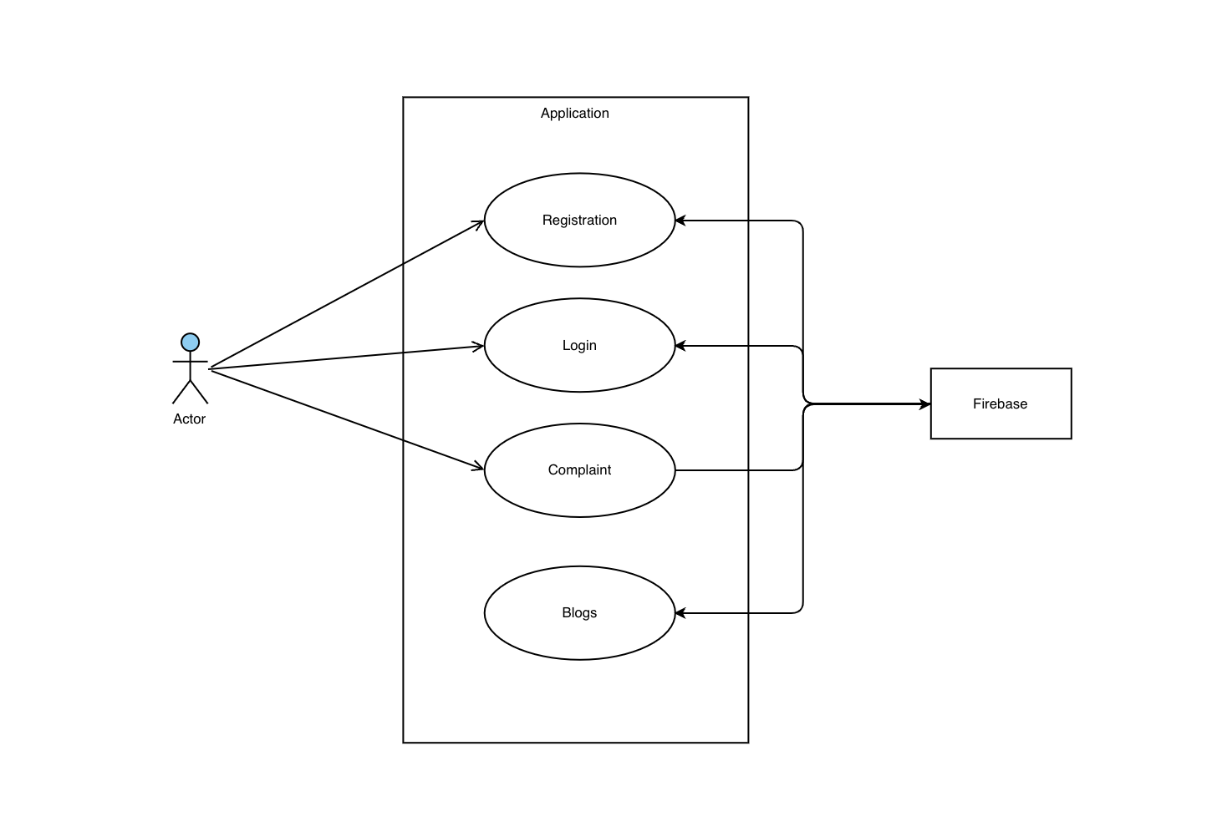**

Figure 4.4.6 Use-Case Diagram

The above figure 4.4.6 Use-Case diagram describes the high-level functions and scope of the system. This diagramalso identifies the interactions between the system and its actors.

1. **ACTIVITY DIAGRAM**

An activity diagram is a behavioral diagram i.e. it depicts the behavior of a system. An activity diagram portrays the control flow from a start point to a finish point showingthe various decision paths that exist whiletheactivityis being executed.

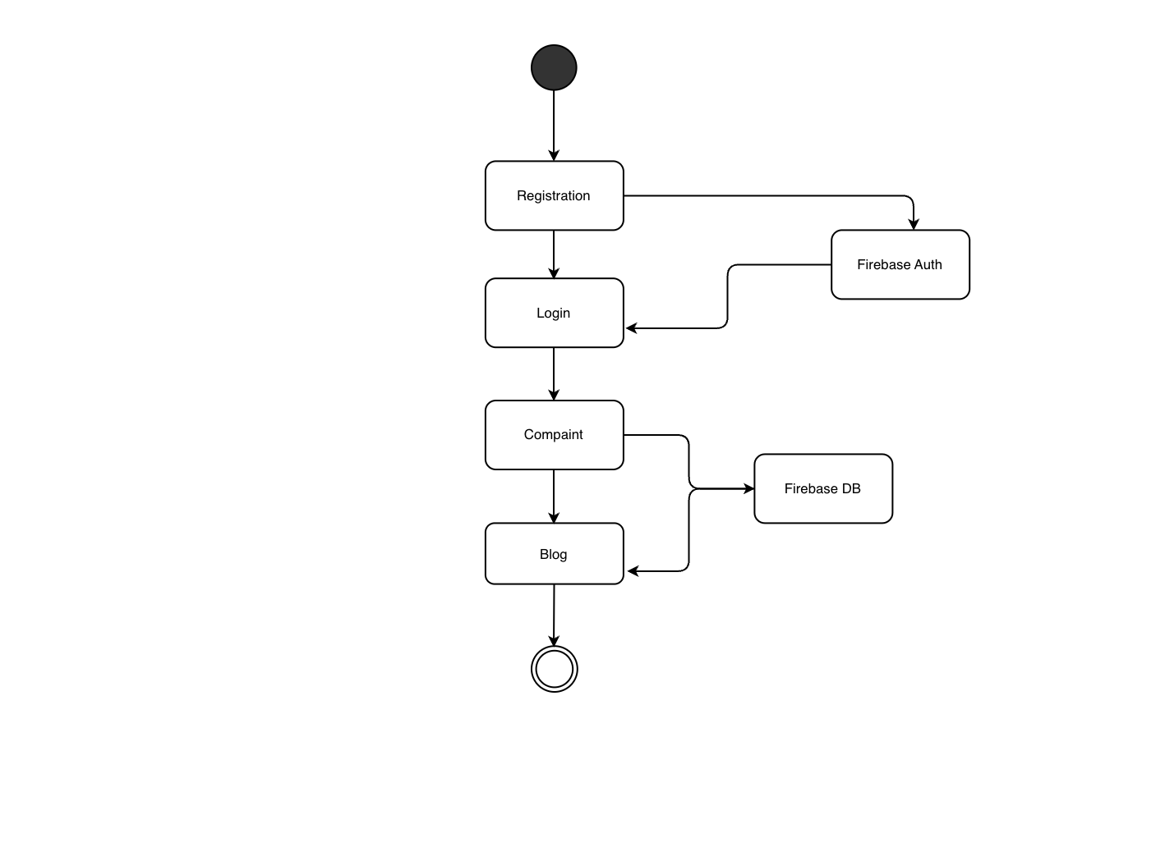

Figure 4.4.7 Activity Diagram

The above figure 4.4.7 Activity Diagram, depicts the behavior of the system. It shows the control flow fromstart to finish point by showing different decision paths that are existed in the system.

1. **SEQUENCE** **DIAGRAM**

Asequence diagram showsobject interactions arranged in time sequencein the field of software engineering. It depicts the objects involved in the scenario and the sequence of messages exchanged between the objects needed to carry out the functionalityof the scenario.

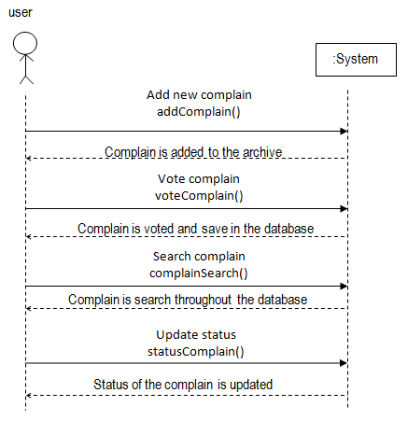

Figure 4.4.8 Sequence Diagram0

The above figure 4.4.8 Sequence diagram shows the process interactions arranged in time sequence for the developing system.

1. **CLASS DIAGRAM**

The Class Diagram is a static structure type that describes the structure of the system by showing the system classes, its attributes, operations (or methods), and relationships among objects. Class Diagrams are the main building block in Object-Oriented Modelling. The Class Diagram represents the static view of the application.

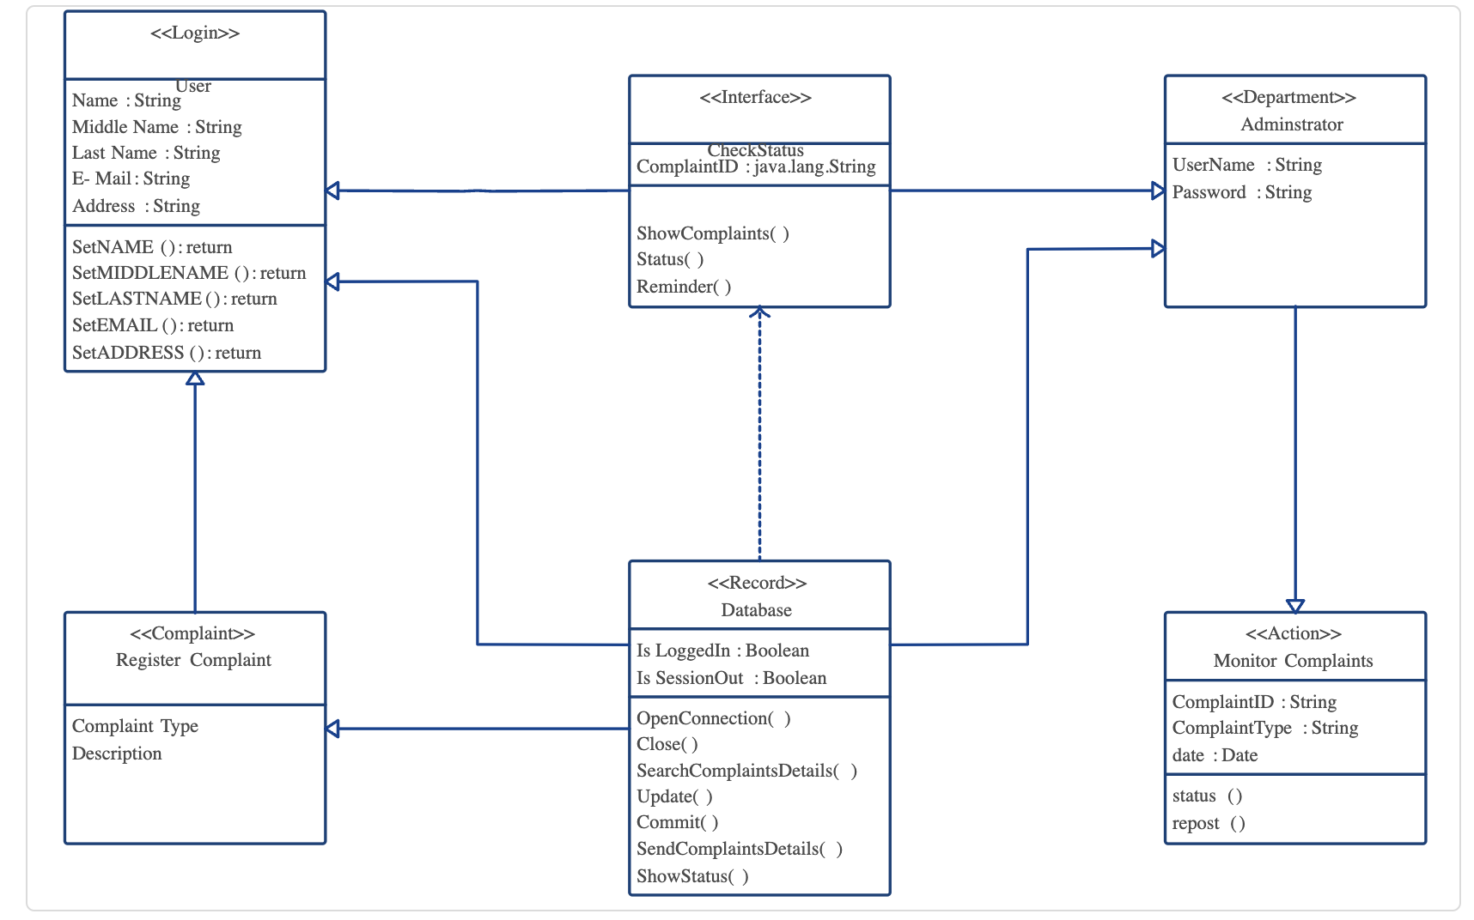

Figure 4.4.9 Class Diagram

The above figure 4.4.9 Class Diagram is like a blueprint of a systemor subsystem. It describes the system’s structure in a detailed way, showing its attributes, operations as well as its inter-relationships.

**CHAPTER**

**V**

**PROJECT PLAN**

**5.1 OVERVIEW OF PROJECT IMPLEMENTATION**

we are focusing on real world problem as we know the day to day life of every normal person is not easy, they have some issues like water supply, light issues,road issues,job issue. our project is aspired for to overcome this issues. In our project there have a complaint box in that the peoples write down there complaints and we just trying to solve those problems as early as possible, after solving the problems we will get the feedback from the peoples and then we add it into our blog's. we have created a blog's page in that we are show our social work, in that we have photos and text of what social work we have done. after that we have created the team up,in that every person can join us to help other peoples.after sending the blog's or notification from admin, we have created notification recive for user side. the blog have gallery which are show are going to showcase on main screen( only photos or banner).our project have a login/logout and forgot password and also have a create new account functionality.

**5.2 TOOLS AND TECHNOLOGIES USED**

**Programming** **Language:** Javascript

**Platform:** Windows and MAC

**IDE:** Visual Studio Code

**5.3 SOFTWARE INFORMATION**

**JAVASCRIPT :** JavaScript, often abbreviated as JS, is a programming language that is one of the core technologies of the World Wide Web, alongside HTML and CSS. As of 2022, 98% of websites use JavaScript on the client side for webpage behavior, often incorporating third-party libraries. All major web browsers have a dedicated JavaScript engine to execute the code on users' devices. JavaScript is a high-level, often just-in-time compiled language that conforms to the ECMAScript standard. It has dynamic typing, prototype-based object-orientation, and first-class functions. It is multi-paradigm, supporting event-driven, functional, and imperative programming styles. It has application programming interfaces (APIs) for working with text, dates, regular expressions, standard data structures, and the Document Object Model (DOM). The ECMAScript standard does not include any input/output (I/O), such as networking, storage, or graphics facilities. In practice, the web browser or other runtime system provides JavaScript APIs for I/O. JavaScript engines were originally used only in web browsers, but are now core components of some servers and a variety of applications. The most popular runtime system for this usage is Node.js. In November 1996, Netscape submitted JavaScript to Ecma International, as the starting point for a standard specification that all browser vendors could conform to. This led to the official release of the first ECMAScript language specification in June 1997. The standards process continued for a few years, with the release of ECMAScript 2 in June 1998 and ECMAScript 3 in December 1999. Work on ECMAScript 4 began in 2000. Meanwhile, Microsoft gained an increasingly dominant position in the browser market. By the early 2000s, Internet Explorer's market share reached 95%.This meant that JScript became the de facto standard for client-side scripting on the Web. Microsoft initially participated in the standards process and implemented some proposals in its JScript language, but eventually it stopped collaborating on Ecma work. Thus ECMAScript 4 was mothballed. Meanwhile, very important developments were occurring in open-source communities not affiliated with ECMA work. In 2005, Jesse James Garrett released a white paper in which he coined the term Ajax and described a set of technologies, of which JavaScript was the backbone, to create web applications where data can be loaded in the background, avoiding the need for full page reloads. This sparked a renaissance period of JavaScript, spearheaded by open-source libraries and the communities that formed around them. Many new libraries were created, including jQuery, Prototype, Dojo Toolkit, and MooTools.

**Visual Studio Code :** Visual Studio Code, also commonly referred to as VS Code, is a source-code editor made by Microsoft with the Electron Framework, for Windows, Linux and macOS. Features include support for debugging, syntax highlighting, intelligent code completion, snippets, code refactoring, and embedded Git. Users can change the theme, keyboard shortcuts, preferences, and install extensions that add additional functionality. In the Stack Overflow 2021 Developer Survey, Visual Studio Code was ranked the most popular developer environment tool among 82,000 respondents, with 70% reporting that they use it.Visual Studio Code was first announced on April 29, 2015, by Microsoft at the 2015 Build conference. A preview build was released shortly thereafter.On November 18, 2015, the source of Visual Studio Code was released under the MIT License, and made available on GitHub. Extension support was also announced. On April 14, 2016, Visual Studio Code graduated from the public preview stage and was released to the Web.Microsoft has released most of Visual Studio Code's source code on GitHub under the permissive MIT License, while the releases by Microsoft are proprietary freeware.Visual Studio Code is a source-code editor that can be used with a variety of programming languages, including Java, JavaScript, Go, Node.js, Python, C++, C, Rust and Fortran.It is based on the Electron framework, which is used to develop Node.js web applications that run on the Blink layout engine. Visual Studio Code employs the same editor component (codenamed "Monaco") used in Azure DevOps (formerly called Visual Studio Online and Visual Studio Team Services).Out of the box, Visual Studio Code includes basic support for most common programming languages. This basic support includes syntax highlighting, bracket matching, code folding, and configurable snippets. Visual Studio Code also ships with IntelliSense for JavaScript, TypeScript, JSON, CSS, and HTML, as well as debugging support for Node.js. Support for additional languages can be provided by freely available extensions on the VS Code Marketplace. An orange version of the Visual Studio Code logo for the insiders version of Visual Studio Code Visual Studio Code Insiders logo Instead of a project system, it allows users to open one or more directories, which can then be saved in workspaces for future reuse. This allows it to operate as a language-agnostic code editor for any language. It supports many programming languages and a set of features that differs per language. Unwanted files and folders can be excluded from the project tree via the settings. Many Visual Studio Code features are not exposed through menus or the user interface but can be accessed via the command palette. Visual Studio Code can be extended via extensions, available through a central repository. This includes additions to the editor and language support.A notable feature is the ability to create extensions that add support for new languages, themes, debuggers, time travel debuggers, perform static code analysis, and add code linters using the Language Server Protocol. Source control is a built-in feature of Visual Studio Code. It has a dedicated tab inside of the menu bar where users can access version control settings and view changes made to the current project. To use the feature, Visual Studio Code must be linked to any supported version control system (Git, Apache Subversion, Perforce, etc.). This allows users to create repositories as well as to make push and pull requests directly from the Visual Studio Code program. Visual Studio Code includes multiple extensions for FTP, allowing the software to be used as a free alternative for web development. Code can be synced between the editor and the server, without downloading any extra software. Visual Studio Code allows users to set the code page in which the active document is saved, the newline character, and the programming language of the active document. This allows it to be used on any platform, in any locale, and for any given programming language.[promotional language] Visual Studio Code collects usage data and sends it to Microsoft, although this can be disabled. Due to the open-source nature of the application, the telemetry code is accessible to the public, who can see exactly what is collected. VSCodium provides binary releases of VS Code without MS branding/telemetry/licensing. VSCodium is a community-driven, freely-licensed binary distribution of Microsoft’s editor VS Code minus the proprietary opaque code and Microsoft's telemetry. These binaries are licensed under the MIT license.

**CHAPTER**

**VI**

**METHODOLOGY**

**6.1** **ALGORITHM** **DETAILS**

**6.3.1** **Collaborative** **filtering** **algorithm:**

The Collaborative filtering algorithm is the technique which is used to filter the Voter details every user can search his name in any formate for that thing we need to search every single word with database result name and that the whole goal about these algorithm. In this algorithm, the users looks at the voters they may find anothers name or own name are in sameer jawalkars ward or not. In Collaborative Filtering algorithm, it finds similar voters and recommends what the similarity voter like. In recommendation system, it don’t use the features of the items to recommend, rather we classify the voter into the search bar of similar types, and recommend each voter name according to the preference of its search bar.

It works by searching a large group of voters and finding a smaller set of voter details with tastes similarto a particular user. also after picking up that person we can see the whole details of that person with its name, address and much more.

**Collaborative** **Filtering** **Be** **Used?**

Collaborative filtering works around the interactions that users have with items. These interactions can help find patterns that the data about the items or users itself can’t. Here are some points that can help you decide if collaborative filtering can be used:

* Collaborative filtering doesn’t require features about the items or users to be known. It is suited for a set of different types of items, for example, a supermarket’s inventory where items of various categories can be added. In a set of similar items such as that of a bookstore, though, known features like writers and genres can be useful and might benefit from content-based or hybrid approaches.
* Collaborative filtering can help recommenders to not overspecialize in a user’s profile and recommend items that are completely different from what they have seen before. If you want your recommenderto not suggest apair ofsneakersto someone who just bought another similar pair of sneakers, then try to add collaborative filtering to your recommender spell.

**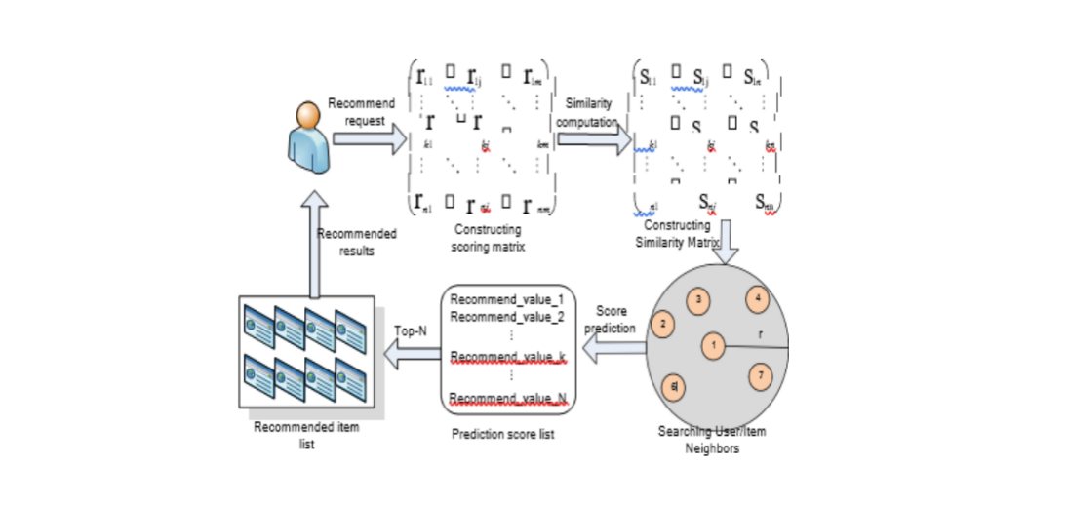**

**6.3.2** **Sequencial Search** **Algorithm :**

In computer science, a sequential algorithm or serial algorithm is an algorithm that is executed sequentially – once through, from start to finish, without other processing executing – as opposed to concurrently or in parallel. The term is primarily used to contrast with concurrent algorithm or parallel algorithm; most standard computer algorithms are sequential algorithms, and not specifically identified as such, as sequentialness is a background assumption. Concurrency and parallelism are in general distinct concepts, but they often overlap – many distributed algorithms are both concurrent and parallel – and thus "sequential" is used to contrast with both, without distinguishing which one. If these need to be distinguished, the opposing pairs sequential/concurrent and serial/parallel may be used.

**Sequencial**  **Filtering** **Be** **Used?**

The Sequantial Filtering is mostly used when data is locally stored and need to perform it faster for and in sequensial maner so now our voter data is not on the web but its on the local storage and we want to fetch every single voter name with searching value so these algorithm is helpfull there because if we try to miss any single value then it will complete failure for our app result that we get is in json format so that why there are some basic functions we can use also at the first page means at the voter id page we are only showing 200 voters just because of scalability.

**CHAPTER**

**VII**

**CONCLUSION**

**Conclusion :**

These application are splited in 2 part one application is made for users and one for admin both have different approchase and they both required one single sort of database to put and retrive value by these study report now understand what things that we need really take care in and how much functionality the application have basically the functionality are made for user app and admin app is handling those things but because its a sponsor project the client requirement is also matter for use if client want to use another way for doing the thing they we need to do some changes into it as well and may impact on our algorithms or some basic things.

**APPENDIX**

**A**

**REFERENCES**

**References :**

* Thivanon Kansuwan,Thawatchai chomaski: Authentication Model using the Bundled CAPTCHA OTP Instead of Traditional Password 2019,IEEE.
* Feyzullah Kalyoncu, Engin Zeydan, Ibrahim Onuralp Yigit, and Ahmet Yildirim : A Customer Complaint Analysis Tool for Mobile Network Operators,2018 IEEE.
* Kewal shah, Harsh Sinha, Payal mishra : Analysis of Cross-Platform Mobile App Development Tools,2019 IEEE.

**RESEARCH**

**PAPER**

**SYNOPSIS**